# [**Law and Order's Stabler forced to take down love interest as team uncovers ‘rogue mission’**](https://www.express.co.uk/showbiz/tv-radio/1692037/Law-and-Order-Elliot-Stabler-love-interest-rogue)

### Law and Order: Organized Crime could see Elliot Stabler making an impossible decision after revealing an uncomfortable truth about a friend from his past.

By [**LUCAS HILL-PAUL**](https://www.express.co.uk/journalist/122856/Lucas-Hill-Paul)

08:35, Fri, Nov 4, 2022 | UPDATED: 08:49, Fri, Nov 4, 2022

[**0**](https://www.express.co.uk/showbiz/tv-radio/1692037/Law-and-Order-Elliot-Stabler-love-interest-rogue#conversation-wrapper)

### **Law & Order: Organized Crime promo for Promo "All That Glitters"**

0 seconds of 14 secondsVolume 0%

**SUBSCRIBE**

We use your sign-up to provide content in ways you've consented to and to improve our understanding of you. This may include adverts from us and 3rd parties based on our understanding. You can unsubscribe at any time. [More info](https://www.express.co.uk/privacy-notice)

All three [Law and Order](https://www.express.co.uk/latest/law-and-order-svu) series returned for more thrilling investigations on Thursday night, and fans already can’t wait to see what’s next for Olivia Benson (played by Mariska Hargitay) and Elliot Stabler (Christopher Meloni). After this week’s high-stakes mission to take out a group of cop-killers on the hit [NBC](https://www.express.co.uk/latest/nbc) spin-off, [Organized Crime](https://www.express.co.uk/latest/law-and-order-organized-crime), Stabler will have complicated feelings when an old friend helps out on his next case.

### RELATED ARTICLES

* [**The One Show viewers 'switch off' over Greta Thunberg interview 'Oh...**](https://www.express.co.uk/showbiz/tv-radio/1690237/The-One-Show-Greta-Thunberg-switch-off-interview)
* [**Lidl Christmas Advert 2022 sees adorable Lidl Bear take centre stage**](https://www.express.co.uk/showbiz/tv-radio/1691826/lidl-christmas-advert-2022-bear)

Stabler could be forced to put a corrupt cop and a potential love interest behind bars in the next episode of Organized Crime.

This season, Stabler has already uncovered a surprising connection to the NYPD following a frenzied shootout, and Bobby Reyes (Rick Gonzalez) takes his mission to put the perps behind bars a little too far.

For the seventh episode of Organized Crime’s current season, All That Glitters, Stabler welcomes back an old friend, Tia Leonetti (Ayelet Zurer).

This pair clearly have a history together, and her reunion with Stabler could be a hint his love life is about to improve.

**Sponsored**

[**Afternoon EditionRoberta Close já tem 58, tente não sorrir ao ver como ela está agora**](https://afternoonedition.com/trending/essas-celebridades-ainda-estao-na-ativa-e-cheias-de-energia?utm_source=taboola&utm_medium=reach-express&utm_campaign=21536303&utm_term=Roberta+Close+j%C3%A1+tem+58%2C+tente+n%C3%A3o+sorrir+ao+ver+como+ela+est%C3%A1+agora&utm_content=http%3A%2F%2Fcdn.taboola.com%2Flibtrc%2Fstatic%2Fthumbnails%2F138bfe95e99bd9c7dfe7d57bfea501bc.png&ts=2022-11-04+21%3A02%3A34&tbv=ajo8WSv58OIbHPFUYA6WbqOo5oBftQkgG8_ayuXsQxU=&pcl=1&br=1&utm_source=taboola&utm_medium=reach-express&utm_campaign=21536303&utm_term=Roberta+Close+j%C3%A1+tem+58%2C+tente+n%C3%A3o+sorrir+ao+ver+como+ela+est%C3%A1+agora&utm_content=http%3A%2F%2Fcdn.taboola.com%2Flibtrc%2Fstatic%2Fthumbnails%2F138bfe95e99bd9c7dfe7d57bfea501bc.png&ts=2022-11-04+21%3A02%3A34&tbv=ajo8WSv58OIbHPFUYA6WbqOo5oBftQkgG8_ayuXsQxU=&pcl=1&br=1)

[by Taboola](https://popup.taboola.com/en/?template=colorbox&utm_source=reach-express&utm_medium=referral&utm_content=thumbnails-mid:Mid%20Article%20Express:)

**READ MORE:** [**Penny Lancaster in tears recalling Rod Stewart health update reaction**](https://www.express.co.uk/showbiz/tv-radio/1688949/penny-lancaster-crying-rod-stewart-health-update-menopause)

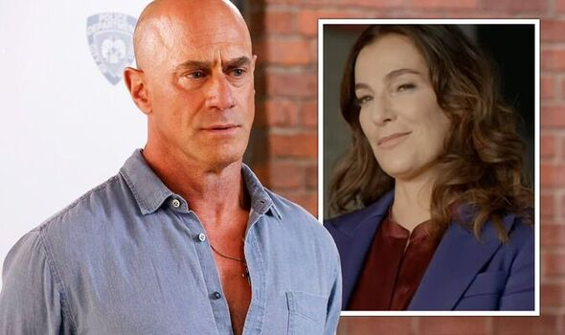

Law and Order: Stabler forced to take down love interest as team uncovers ‘rogue mission’ (Image: NBC)

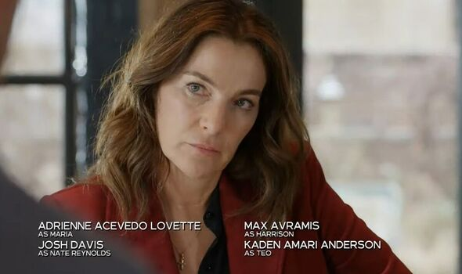

Law and Order: Can Stabler trust Leonetti? (Image: NBC)

### READ MORE

* [**Prince Harry memoir torn apart by Steph McGovern**](https://www.express.co.uk/showbiz/tv-radio/1689420/Prince-Harry-torn-apart-Steph-McGovern)

A synopsis for this episode reads: “The task force goes undercover to bust a jewellery operation they come to realise isn't just smuggling gold.

“An unexpected guest from Stabler's past arrives to help take the operation down and confront some unresolved feelings.”

Although fans have been hoping for Stabler and Benson to get together for almost two decades now, this latest development could sadly be about to crush those dreams.

In the latest promo, Tia suggests “We can combine resources” when Stabler realises they’re working the same case.

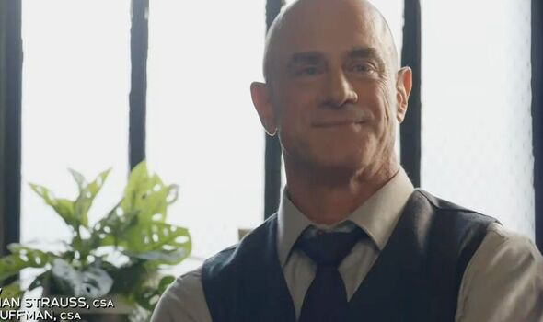

Law and Order: Stabler welcomes back an old friend (Image: NBC)

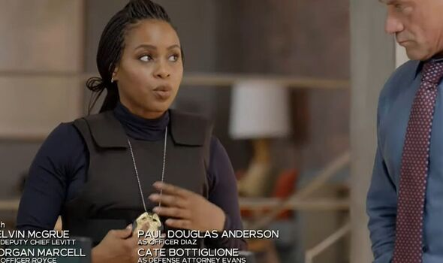

Law and Order: Bell doesn't trust Stabler's new partner (Image: NBC)

The old friends share some looks which could indicate their relationship will be taken to the next level, but Stabler’s colleague Ayanna Bell (Danielle Moné Truitt) isn’t won over by the new arrival.

“She’s a good cop, I can vouch for her,” Stabler insists to his partner.

However, Ayanna reveals, “she’s on a rogue mission,” and footage of Tia taking things into her own hands seems to confirm her suspicions.

Hopefully, Tia won’t be revealed as a dirty cop trying to take advantage of Stabler’s latest investigation to make a quick profit.